A project report on

“CONTACT TYPE HUMAN
BODY PULSE RATE DETECTION
USING CAMERA“
(USING FFT ALGORITHEM)

Submitted By
Ameya Kathapurkar (mug739)
Omkar Paranjape (dyj924)
Swanand Mhalagi (lwv826)

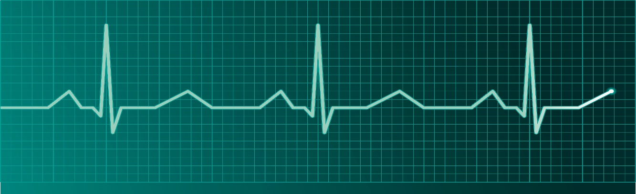

TABLE OF CONTENTS.

 | Caption | Page No.
1) | Abstract | 3
2) | Introduction | 3
3) | Block diagram | 4
4) | DSP algorithm design | 4
5) | Computer Simulation | 7
6) | Performance Evaluation | 9
7) | Conclusion | 10
8) | References | 10
9) | Matlab Code | 11

Abstract:

Measurement of human body pulse can provide accurate assessment of health conditions. Our basic aim is to measure the pulse rate of a human body with the help of smart phone camera. The pulse rate can be measured with the help of medical instruments but we have tried to use the easily available devices for the same purpose. Previous methods used for measurements were tedious to use and harmful to human body. In addition to this, they are not portable and costly. In this approach, we recorded the video of human figure which was in contact with camera lens. After detailed analysis of this video, we have successfully generated frame wise frequency response of the captured signal which will help us to calculate the pulse rate of the human body. For the development of the project, we have used the MATLAB software which gives step wise implementations.

Introduction:

The methods used before for the determination of pulse rate were very costly as various medical instruments were used for the purpose. Also the radiations from these devices can cause hazardous effects on human body. Hence it is advantageous to use the easily available devices which will be used to capture the video and thereafter we can use the concepts in DSP for further implementations.
We are looking for the graph shown above as our final goal which mainly describes the frequency of the signal which can be utilized in determination of the pulse rate. Concepts in DSP are very useful in this process. Fast Fourier Transform is used to obtain the frequency response of the captured signal. The advantage of FFT over DFT is, the calculations required in FFT are much less compared to DFT.
Filters make control over the band which has to be considered in computations. We have used i6 + phone in our project for the demonstration. But any digital camera or smart phone having a camera can be used to work on this project. Thus user does not have to depend on any costly medical equipment for pulse detection. Any layman who has the basic knowledge of handling a mobile device can use this method for generating the pulses. Hence in our opinion, this method which is suggested by MIT people will have huge scope in coming years.

Block Diagram:

DSP Algorithm
The algorithm is basically signal acquisition and computation of its properties in time and frequency domain. Further filtration and waveform shaping is the final step to get beats per minute.
Video Signal Generation
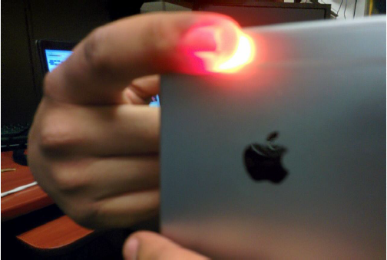

Signal acquisition being the most important step in the process we have obtained the video signal using IPhone 6+ camera by keeping the upper edge of the index figure on the camera and lower part on the in-built LED of the camera. The color of the blood being red and LED focus makes the video Red and due to blood flow variation we get varying brightness of Red color on video. This is that brightness we are interested in and eventually giving the BPM. Basically we are obtaining the frames in this section.
Brightness Signal Computation
Brightness can be computed by observing the intensity variation of every frame that was sampled. For this we take every frame individually and obtain the red plane. This computation formula is taken from MIT research. Further we divide the red plane with frames so that we get average brightness intensity and it is stored in 1*385 matrix.
Band-pass Filtering using Butterworth Approximation

The filter specifications are given in terms of the discrete-time frequency variable and then mapped to a corresponding set of specifications for the continuous-time filter. We have set our limits from 40bpm to 240bpm as they are the limits of pulse rate measurement in humans. So we have set two cut off frequency for the filter to obtain values between these two ranges. Also the iphone6+ have frame rate of 60fps and these value are set in the Butter function as it is band-pass filter. This outputs the values in given range. Butter filter is digital filter that gives us output in discrete pulses.

Fast Fourier Transform
The pulses from Butterworth Filter are used to transform the signal from time domain to frequency domain. FFT gives more efficient output than DFT and is used to reduce complexity of algorithm. The FFT of a real signal is a complex signal in which each complex sample represents the magnitude and the phase of the corresponding frequency. As we do not require the phase we take absolute fft for obtaining the magnitude. FFT also gives high frequency resolution as compared to DFT. The output of FFT gives response that needs to be now further filtered and smoothed to obtain accurate pulse rate.

Sliding Window Analysis

This is the process of taking each window for a short span and performing analysis for 0.5 seconds for a period of 12seconds that is the time for which the video is shot. Operations that are needed to be performed are smoothing and peak detection. The higher the window duration the better is the frequency resolution. We propose to use Hann function that will be used to generate the window. Peak detection is to be done using the MAX function that will detect peaks after the FFT computation. Smoothing is to be yet thought about. Post smoothing the accurate results can be obtained from the graph.

Computer Simulation:

For simulation purpose, we have used METLAB
The steps followed for the process are as follows:

Video Acquisition:



We generated the video, by keeping the finger on the camera and making LED on due to which it gives red coloured output.

Frame wise brightness calculation:

Generated video is divided in frames and brightness of each frame is calculated by using the formula given in MIT paper.

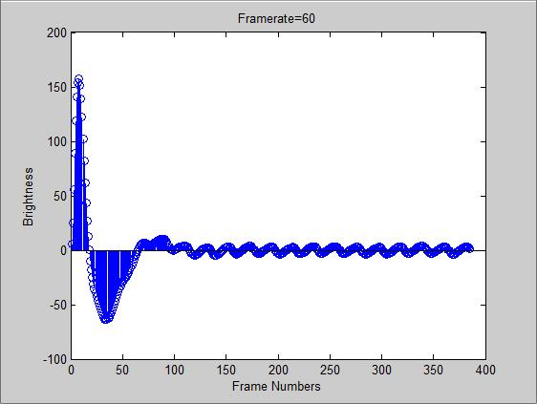

Frequency Determination using FFT:

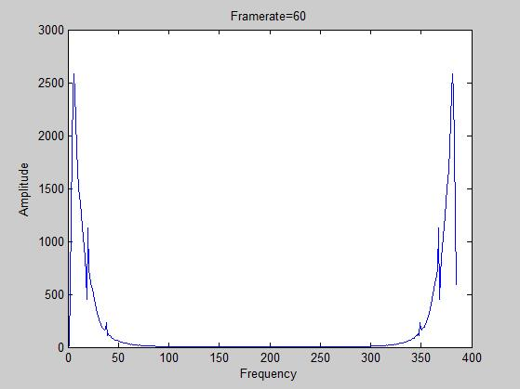

Frequency of the signal is determined by calculating its FFT.

Performance Evaluations:

We tried to generate the output under different conditions. We examined the variations in output by changing the frame rate. The variations in brightness values and frequency response is shown below

When Frame rate is 20fps:

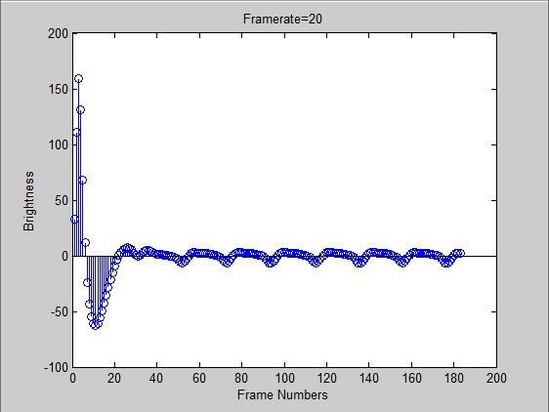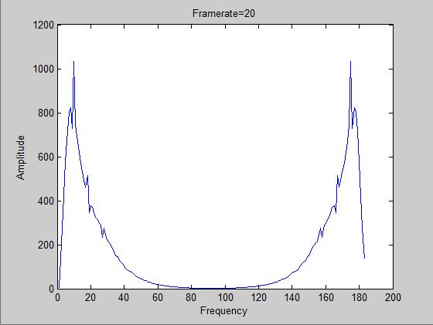

When Frame rate is 60fps:

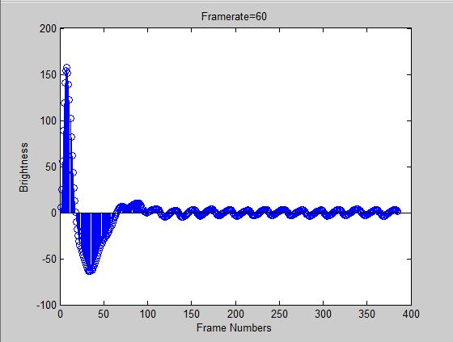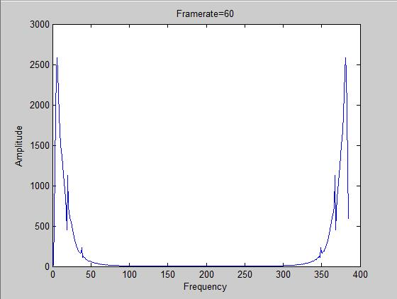

The changes in output can be observed from above figures. Bandwidth of the signals increases with increase in frame rate.

The final goal we are looking to achieve is as shown below:
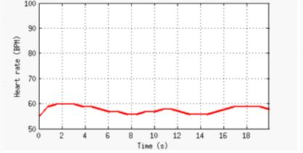

Above result can be obtained once the generated FFT signal goes through smoothing & pulse detection.

Conclusion:
The pulse detection technique employed in this project requires still smoothening and peak detection to get final output in terms of Beats per minute from the graph.This technique is immensely helpful for heart patients to keep track of pulse rate. We propose to use this technique in detection of diseases that is Chinese method of diagnosing diseases using pulse rate. On successful completion of this project we pledge the use of Digital Signal Processing will prove vital for mankind.

References:
[1] Poh, Ming-Zher, Daniel J. McDuff, and Rosalind W. Picard. “Noncontact, automated cardiac pulse measurements using video imaging and blind source separation.” Optics Express 18 (2010): 10762. ©2011 Optical Society of America.
[2] Guha Balakrishnan, Frédo Durand, John Guttag “Detecting Pulse from Head Motions in Video “Computer Vision and Pattern Recognition (CVPR), 2013 IEEE Conference
[3] Hao-Yu Wu, Michael Rubinstein, Eugene Shih, John Guttag, Frédo Durand, William T. Freeman “Eulerian Video Magnification for Revealing Subtle Changes in the World ACM Transactions on Graphics”, Volume 31, Number 4 (Proc. SIGGRAPH), 2012

MATLAB Code:

%%%%%%%%%%%%%%%%%%%% Video Display %%%%%%%%%%%%%%%%%%%%%%%%%%%%%%%%%%%%%%
videoFReader = vision.VideoFileReader('C:\Users\User\Desktop\Spring\DSP\Project 1\I6+.MOV');
videoPlayer = vision.VideoPlayer;
while ~isDone(videoFReader)
videoFrame = step(videoFReader);
step(videoPlayer, videoFrame);
pause(0.04);
end

%%%%%%%%%%%%%%%%%%%%%%%%%%%%%%%%%%%%%% Brightness Calculation %%%%%%%%%%%%%%%%%%%%%%%%%%%%%%%%%%%%%%%%%
brightness=zeros(1,385);
videoPlayer=VideoReader('C:\Users\User\Desktop\Spring\DSP\Project 1\I6+.MOV');
for i = 1:385
frame = read(videoPlayer, i); % frame-by-frame reading
redPlane = frame(:,:,1); % redplane gives intensity information
brightness(i) = sum(sum(redPlane)) / (size(frame, 1) * size(frame, 2));
end

%%%%%%%%%%%%%%%%%%%%%%%%%%%%%%%%%%%%%%%%%%%%%%%%%% Butterworth Filter %%%%%%%%%%%%%%%%%%%%%%%%%%%%%%%%%%%%%%%%%%%%%%%%%%%%%%%%%
BPM_L=40;
BPM_H=230;
FrameRate=60;
[b, a] = butter(2, [((BPM_L / 60) / FrameRate * 2), ((BPM_H/ 60) / FrameRate * 2)]);
%%%%%%%%%%%%%%%%%%%%%%%%%%%%%%%%%%%%%%%%%%%%%%%%%%%%%%%%%%%%%%%%%%%%%%%%%%%%%%%%%%%%%%%%%%%%%%%%%%%% Brightness Filtering %%%%%%%%%%%%%%%%%%%%%%%%%%%%%%%%%%%%%%%%%%%%%%%%%%%%%%%%%%%%%%%%%%%%%%%%%%%%
filtBrightness = filter(b, a, brightness);

figure(1);
stem(filtBrightness);
xlabel('Frame Numbers');
ylabel('Brightness');
title('Framerate=60');
fftbright=abs(fft2(filtBrightness));

figure(2);
plot(fftbright);
xlabel('Frequency');
ylabel('Amplitude');
title('Framerate=60');

